COMPUTER NETWORK
INTERNETWORKING

Introduction of internetworking
We have studied till now about the homogenous categories of networks in which same protocol for each layer get used. Under this unit you are going to study that network can be of different types & when communication goes from one different network(s) to other different network(s) then this phenomena of communication is called Internetworking.
The advantage of internetworking is that it allows one user on particular different network to communicate with other user on some different network.
Four types of connecting devices, each works at different layer –
S.No. | Layer | Connector | Function
 | Layer – 1 (Physical) | Repeaters | Copy each bit between cable segments
 | Layer – 2 (Data Link) | Bridges | They used to store & forward data link frames
 | Layer – 3 (Network) | Routers | It provide interface or link between two separate but same type of LANs
 | Layer – 4 to 7 ( Transport, Session, Presentation, Application) | Gateways | It provide translation or conversion services between incompatible LANs or applications

DIFFERENCES IN NETWORKS

There are certain factors which makes one network different from other network means these are the factors on the basis of which one network differs with other network. These are as follows –
- Services offered – Some network provides connection oriented service & some provide connectionless service.
- Protocols Used – Different – different network provides different – different protocols like a network can use any of these networks – IP, ATM, HDLC, SNA, Apple Talk etc.
- Addressing – Networks can use different – different type of addressing like Flat (802) versus Hierarchical (IP) etc
- Casting – Few networks use multicasting, few use broadcasting etc.
- Packet size – Every network has some fixed definition of packet size, which is allowed to flow over the network.
- Quality of Service – Networks can provide different Quality of Services.
- Error Handling – Different type of error handling mechanism get used by different – different Networks like checksum, Cyclic Redundancy Check (CRC) etc.
- Flow Control – Different – different Networks follow different – different flow control mechanism, like few uses sliding window protocol (window size may vary in each network) or rate control mechanism.
- Congestion Control - Different – different Networks follow different – different congestion control mechanism, like leaky bucket or token leaky bucket or choke packet.
- Security – Different – different security mechanisms & encryption techniques get used by different – different networks.
- Accounting – Some mathematical notions get calculated for different – different networks like connecting time, timeouts & other flow specifications.

Connecting Networks
Networks can be connected by different devices.
- In the physical layer, networks can be connected by repeaters or hubs, which just move bits from one network to other network.

- One layer up, that is at Data Link Layer we have bridges & switches which operate at Data Link Layer. They can accept frames, examine MAC address & forward the frames to a different network while doing protocol translation. For Eg. – From Ethernet to FDDI or 802.11.

- In the network layer, we have routers that can connect two N/Ws. If the two N/Ws have dissimilar N/W layers, the router may be able to translate between the packet formats, although packet translation is rare.
A router that can handle multiple protocols is called multiprotocol router.

- In the transport layer we find transport gateways, which can interface between two transport connections.
For Eg. - A transport gateway could allow packets to flow between a TCP N/W & an SNA N/W, which has different transport protocol.

In the application layer, application gateways translate message semantics.

<Diagram 5.44 (a) & 5.44 (b)>
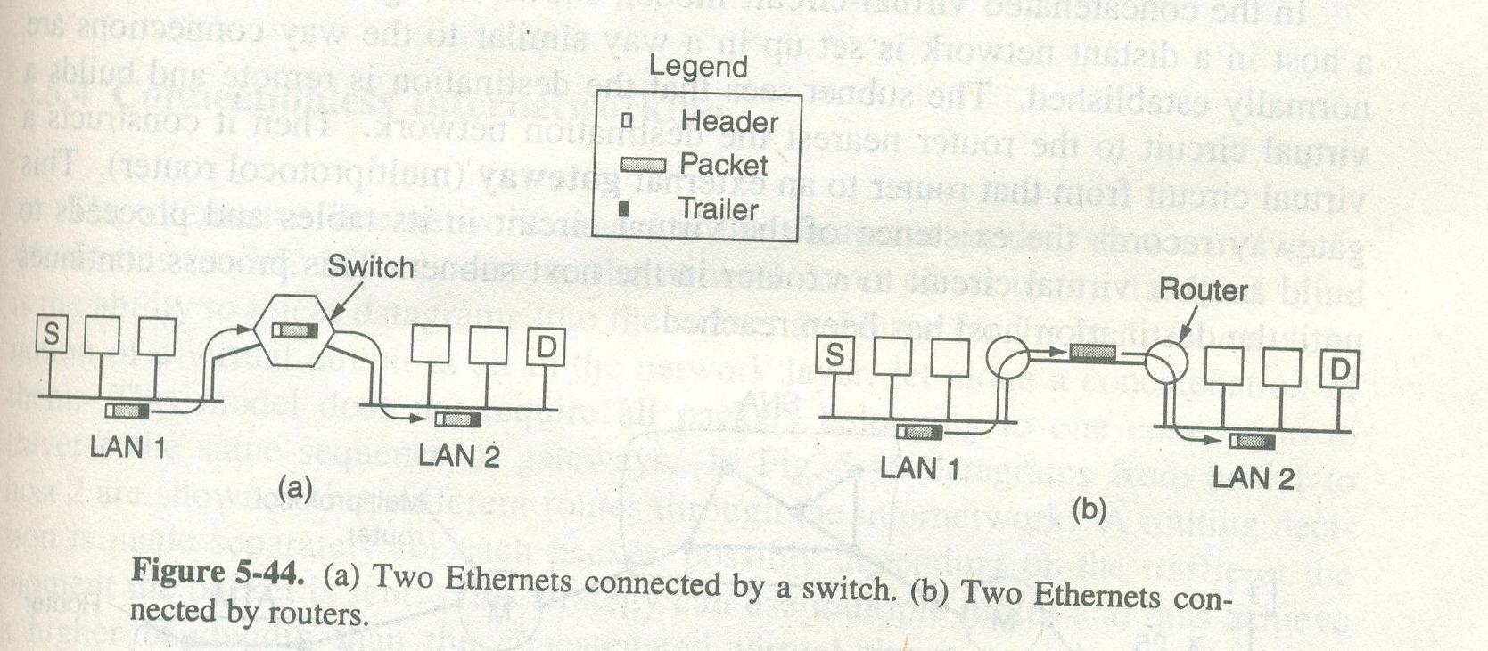

In Fig – 5.44 (a), the source machine S wants to send a packet to the destination machine D. These machines are on different Ethernets, connected by switch. S encapsulates the packet in a frame & sends it on its way. The frame arrives at the switch, which then determines that the frame has to go to LAN-2 by looking at the MAC address. The switch just removes the frame from LAN-1 & deposits it to LAN-2.

Now let us consider the same situation but with the two Ethernets connected by a pair of routers instead of switch. The routers are connected by a point to point line. Now the frame is picked up by the router and the packet get removed from the frame’s data field. The router examines the IP address in the packet & looks up this address in its routing table. Based on this address, it decides to send the packet to the remote router, sometimes encapsulated in a different kind of frame depending on protocol. At the other end, the packet is put into the data field of an Ethernet frame & deposited onto LAN-2.

There is some difference between switch’s case & router’s case. With the switch (or bridge), the entire frame is transported on the basis of its MAC address. With a router, the packet is extracted from the frame and the address in the packet is used for deciding where to send it. Switches don’t have to understand the N/W layer protocol being used to switch packets, routers do.

Concatenated Virtual Circuits

Two styles of internetworking is possible –
- A connection oriented concatenation of virtual circuit subnets
- A datagram internet style

<Fig 5.45>
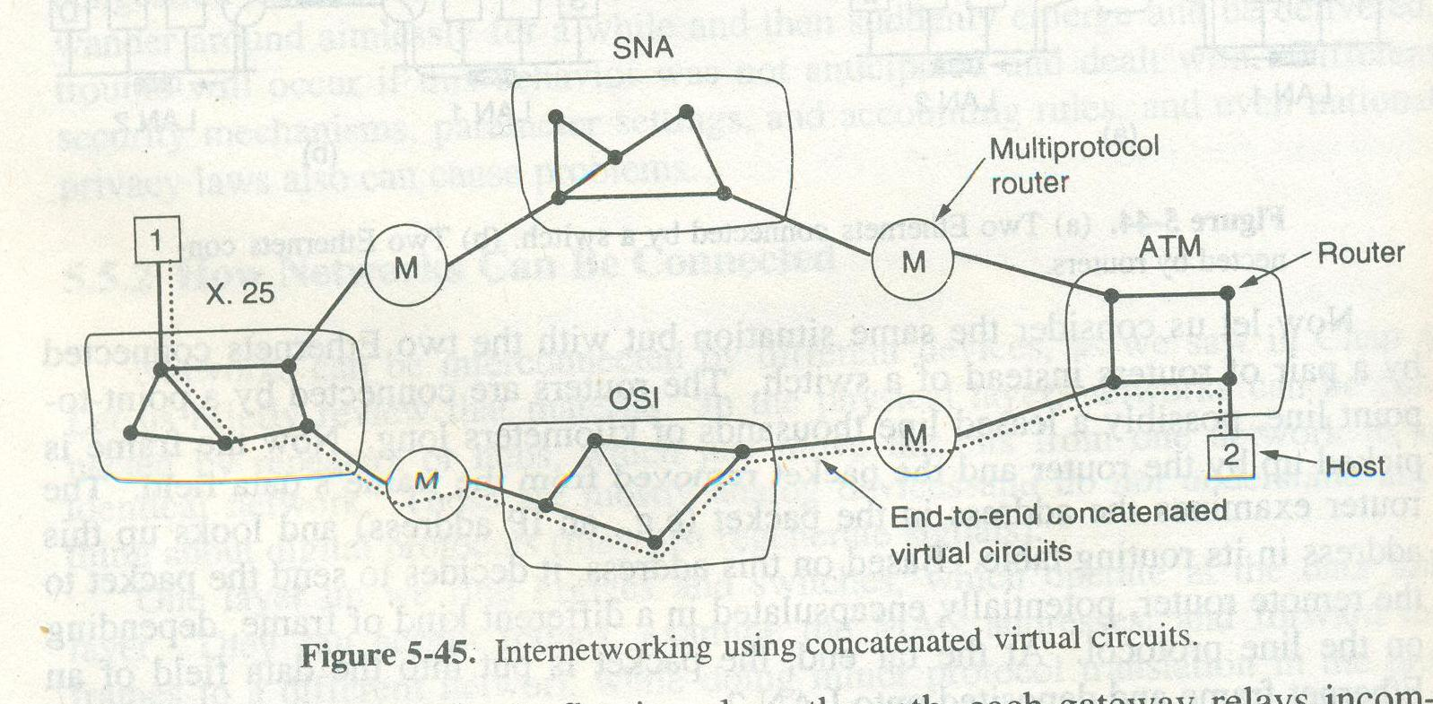

- In a concatenated virtual circuit model, shown in above figure a connection to a host in a distant network is setup as usually connections established.
- The subnet sees that the destination is remote & builds a virtual circuit to the router nearest the destination network.
- It constructs a virtual circuit from that router to an external gateway (multiprotocol router). This gateway records the existence of the virtual circuit in its tables & proceeds to buid another virtual circuit to a router in the next subnet. This process continues until the destination host has been reached.
- The important feature of this approach is that a sequence of virtual circuits is set up from the source through one or more gateways to the destination.
- Each gateway maintains a table telling which virtual circuits pass through it, where are to rotate & what the new virtual circuit number is.
- This scheme works best when all the N/Ws have roughly the same property. Such as reliable delivery or non reliable delivery.

Connectionless Internetwroking

<Fig 5.46>
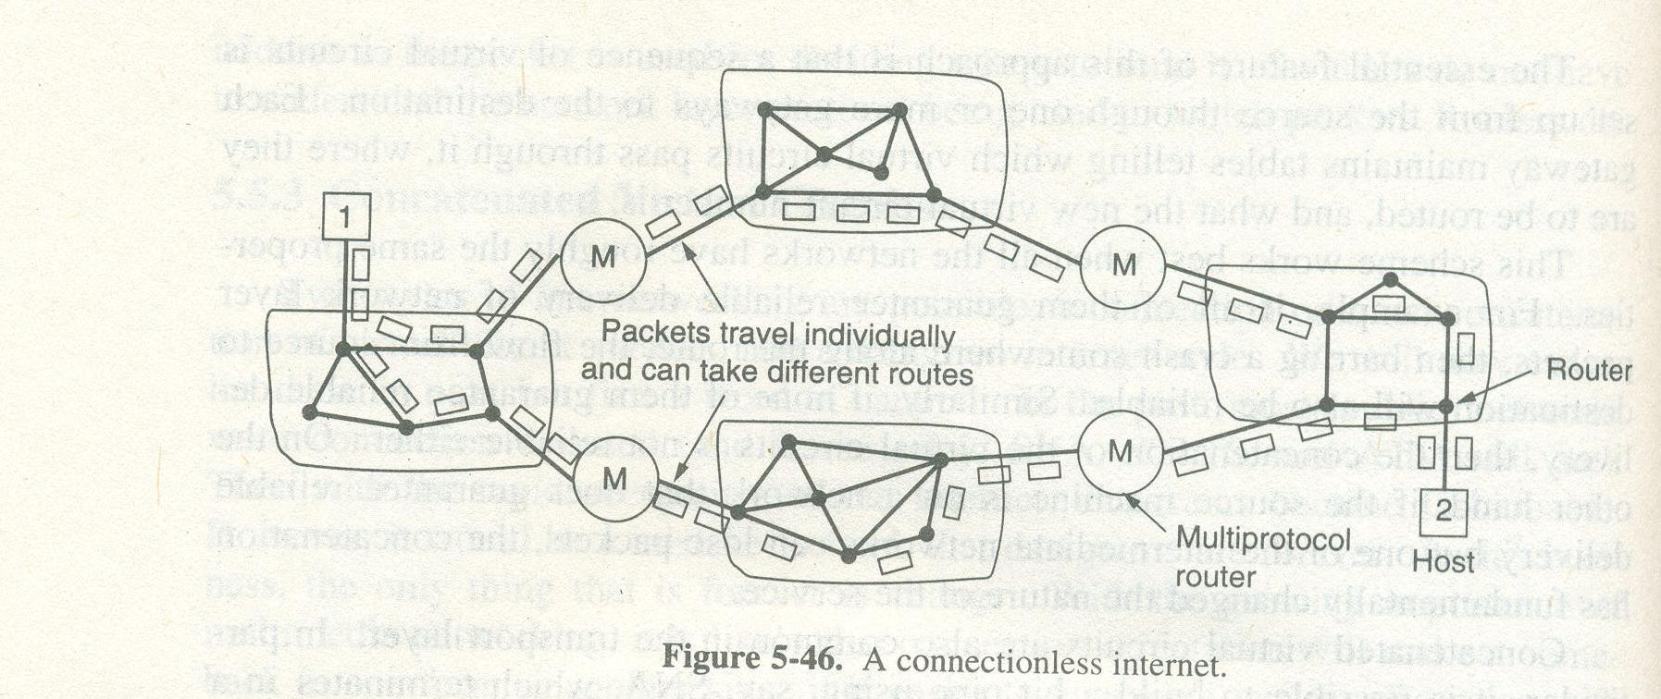

- This style of internetworking uses the datagram funda. In this model, the only service the N/W layer offers, the ability to inject datagrams into the subnet.
- In this all packets doesn’t follow the same one connection to traverse the same sequence of gateways.
- In the above figure datagram(s) from host 1 to host 2 takes different route through the internetwork.
- For every packet, routing decision is made separately depending upon traffic at that time.

Advantage:
This strategy can use multiple routes & thus achieve a higher bandwidth than the concatenated virtual circuit model.

Disadvantage:
- This technique provides no guarantee that the packets will arrive in the same order.
- This approach is quite complex.
- If each N/W has its own N/W layer protocol, its not possible for a packet from one N/W to transmit another one.
- Another disadvantage is of facing differences in addressing. For eg. A host on internet is trying to send an IP packet to a host on another network like SNA. The IP & SNA address are different.

Comparison between Concatenated Virtual Circuit Model & Datagram Model

Advantages of Concatenated Virtual Circuit Model –
- Buffer can be reserved in advance.
- Guaranteed sequencing.
- The problem caused by delayed duplicate packets can be avoided.
- Short headers can be used.

Disadvantages of Concatenated Virtual Circuit Model –
- Entry for each open connection is also maintained in routing table.
- There is no alternate route to avoid the congestion areas.
- This scheme is vulnerable to router failure along a path.

Advantage of Datagram Model –
- Congestion problem get tackled in better way.
- Its more robust in case of router failures.
- Many routing algorithms can get used, means many algorithm options for implementation.

Disadvantage of Datagram Model – The four points written in rectangle are disadvantages of datagram model.

TUNNELING
Sometime source & destination hosts are on the same type of N/W, but there is a different N/W in between them, then there may occur problem for transmission.

<Fig – 2.5/ RTU Book>
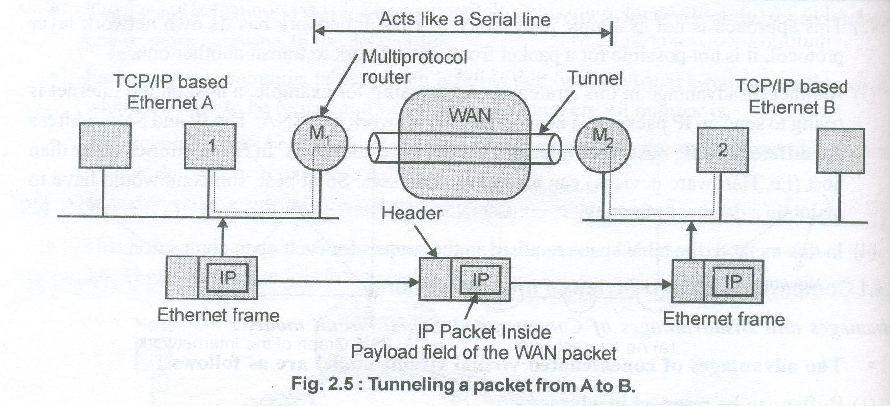

- In the above figure host 1 is existing in TCP/IP based Ethernet A & host 2 in TCP/IP based Ethernet B & a non IP WAN existing in between.
- Now the task is to send packet(s) from host 1 to host 2.
- Solution to this problem is tunneling.
- First host 1 constructs the IP packet into an Ethernet frame. This frame is addressed to multiprotocol router M.
- Host 1 puts this frame on Ethernet.
- When M₁ receives the frame, it inserts in the payload packet of the WAN N/W layer packet & addresses the WAN packet to multiprotocol router M₂.
- Router M₂ removes the IP packet & sends it to host B inside an Ethernet frame.
- Here routers M₁ & M₂ has the capability to interact with the IP packets & WAN standard means host 1 & host 2 doesn’t interact with the WAN packets. So WAN can be imagined as a big tunnel between the multiprotocol router M₁ & M₂.

INTERNETWORK ROUTING

- Internetwork Routing is similar to routing in subnets. In Internetwork Routing, the packet propagates network by network whereas; in other case the packet gets propagated in a single subnet or N/W.

<Fig – 2.6 (a)> & <Fig – 2.6 (b) RTU Book>
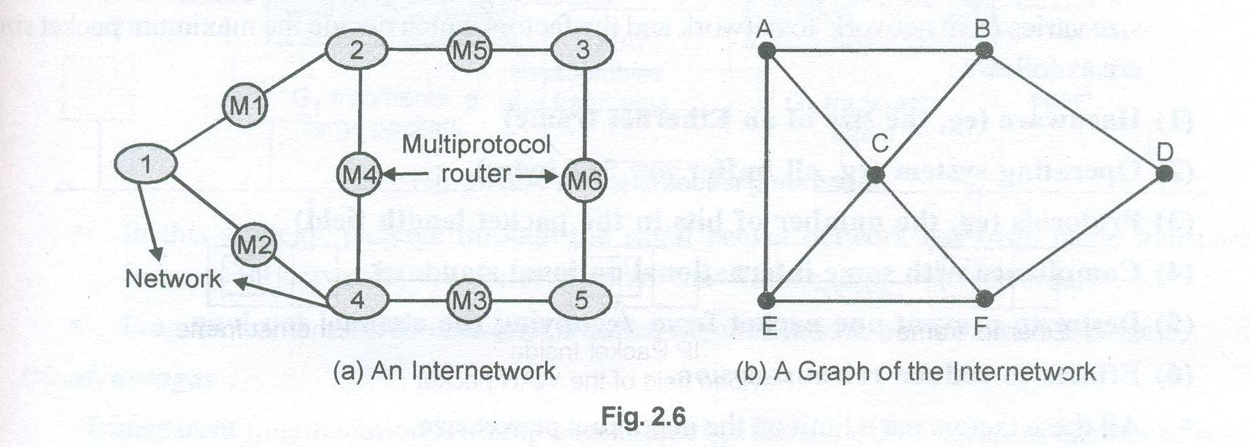

- The above figure shows an internetwork of 5 N/Ws that are connected to each other by six multiprotocol routers (M₁ to M₆). Fig 2.6(b) shows the graph of N/W.
- After constructing this graph, the next motive is to deploy some routing algorithm such as Distance Vector or Link State Routing Algorithm.
- Two levels of routing algorithm get used in internetworking routing. Within a network interior gateway protocol is used & between two networks the exterior gateway protocol is used.
- All the networks in internetwork are different & independent from each other & therefore is called Autonomous System.
- An IP packet contains LAN address first goes to the local multiprotocol router.
- After then the network layer decides which multiprotocol router or exterior gateway to forward the packets to using its own routing table.

There is a difference between internetwork routing & intranetwork routing –
- Internetwork routing may require crossing international boundaries hence need to tackle the differences in laws.
- Internetwork routing may cost differently associated with different routes, even from same source to same destination (means same source se same destination but from different – different routes cost differently).
- In internetwork routing, the Quality of Service (QoS) provided by different – different networks differs. Selecting the optimized route is also time consuming job which varies network by network.

FRAGMENTATION

Each N/W imposes some maximum size on its packets. These limits are due to various causes-
- Hardware used in network means largeness of network in terms of hardware.
- Type of OS used in N/W.
- Type of protocol used.
- Compliance with some (inter)national standard.
- Desire to reduce error induced retransmissions.
- Desire to prevent one packet from occupying the channel too long.

An obvious problem appears when a large packet wants to travel through a network whose maximum packet size is small (means bheje jaane waale packet ka size to bada hai but network small packet size ko hi travel/ propagate karna allow kar raha hai).
Solution to this problem is to allow gateways to break up the packets into chunks called fragments means sending each fragment as separate IP packet. At the destination, fragments are recombined to be back into the original packet form.

Two strategies exists for this recombination –
- Transparent strategy – In this strategy, the fragmentation caused by a “small packet” network transparent to any subsequent networks through which the packet must pass on its way to ultimate destination.
<This option is shown in Fig 5.50 (a) & (b) CN - Tanenbaum>
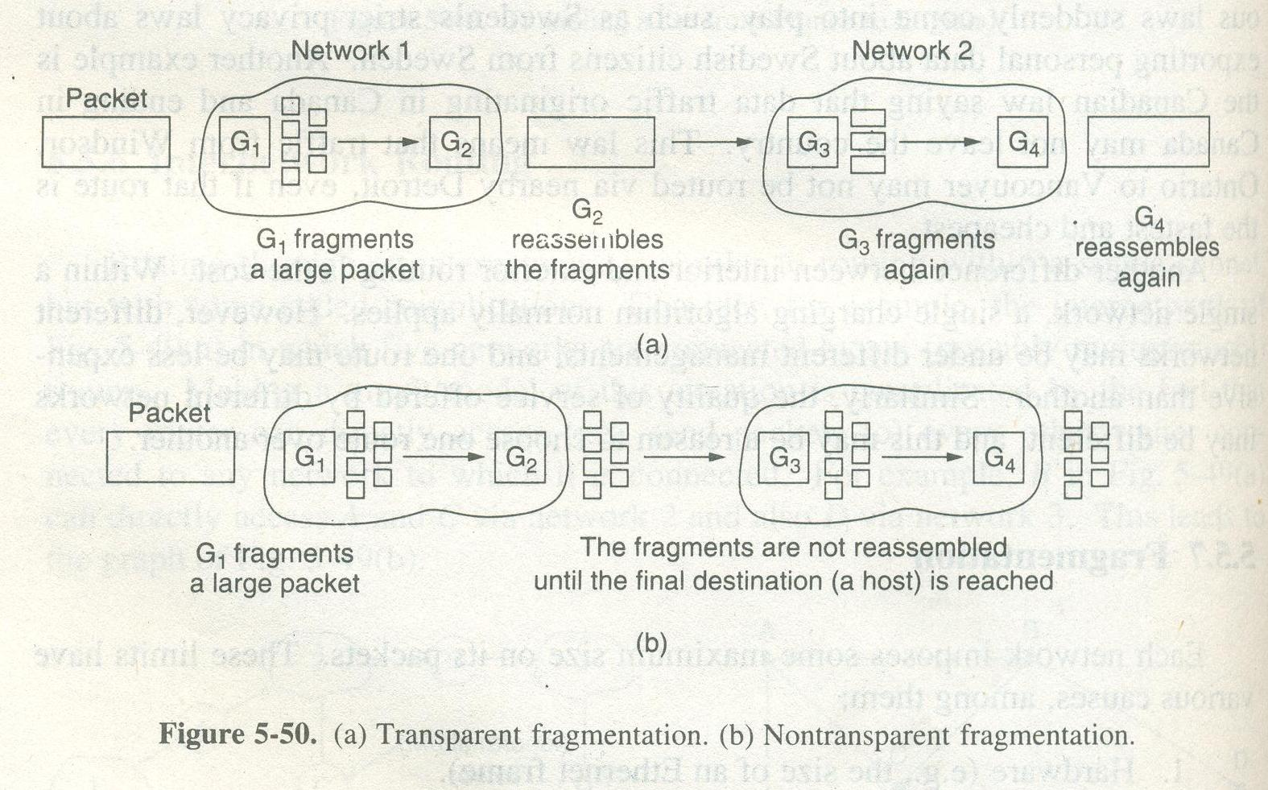
- The small packet network has gateways that interface to other networks. When an oversized packet arrives at a gateway, the gateway break up into fragments.
- Each fragment is addressed to the same exit gateway where the pieces are recombined. In the above figure the exit gateway (G₂) recombines all the fragments.
- In this strategy, passage through the small packet N/W has been made transparent keeping the subsequent N/Ws unaware about fragmentation.
- This phenomenon of fragmentation is called Segmentation in ATM networks.
- There are some problems associated with this strategy for eg. The first problem is that exit gateway G₂ has to know when it has received all the pieces. For this some counter needs to get deployed.
- Another important problem factor is that all the packets should exit via same gateway.
- Another problem is the overhead required to repeatedly fragment & reassemble a large packet.

- Non Transparent Strategy – In this strategy the fragmented packets are not reassembled at gateways, instead in this approach each fragment is treated as a separate original packet. All these packets are passed through the exit gateway & recombination is carried out at the destination host as shown in above given figure.
- The advantage of using the non-transparent strategy is that multiple exit gateways can be used to achieve high performance.
- The disadvantage of non-transparent strategy includes reassembling the fragments.
- The other disadvantage is that total overhead gets increases since each fragment must have a header.
- When a packet is fragmented, the fragments will have to be numbered in such a way that they can get combined to reconstruct into the original packet at the destination host.

NETWORK LAYER IN THE INTERNET

Network layer has it’s functionality over the internet by following certain design principles which made it success, such as –

- Ensuring the working – Do not finalize the design until the multiprotocol communication can get ensured.
- Keep it simple - Stay away from complexity.
- Make clear choices – Choose the optimum solution/ standards to opt for network layer.
- Exploit modularity – Means deploy the layers/ protocols into modules so that if one layer gets updated, the other doesn’t get affected.
- Expect heterogeneity – Different type of hardware & related transmission activities may occur so the network design should be flexible enough to handle them properly.
- Think about scalability – If the network needs to handle millions of hosts then no centralized databases/ controlling mechanisms gets deployed. The focus is on scalability means how evenly the load gets spread.
- Consider performance & cost – Performance & cost should be effective.

INTERNETWORK PROTOCOL (IP i.e. IPV4)
IPV4 is the unreliable & connectionless datagram protocol. Each packet called datagram get sent separately. Datagram(s) can follow different routes every time & may reach at the destination host out of order. There is no handshaking process for connection setup as it’s connectionless.

IP Datagram Format:
A datagram has header & data field.

Header is of 20-40 bytes & contains information crucial to routing.
Data is the amount of information that can be transferred from source to destination & it’s between 20 to 65536 bytes.

<Fig 2.9 from RTU Book>
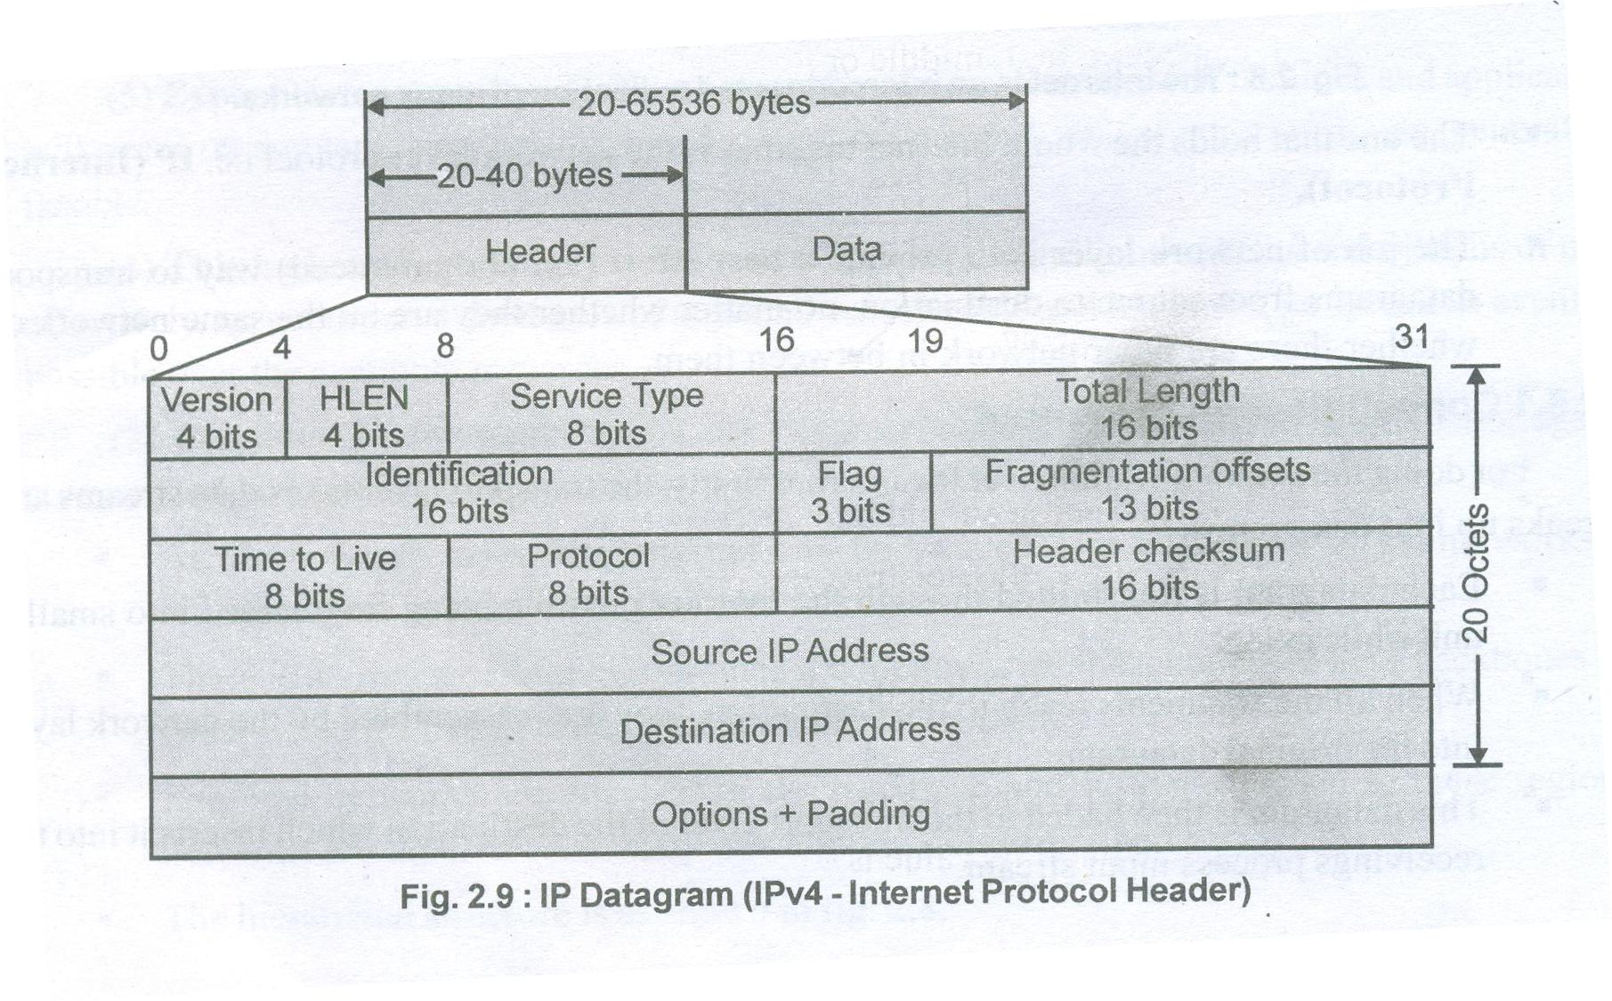

Header can have many other fields like –

- Version – Version field used to mention the version of the protocol like the version is IPV4 or IPV6 etc.
- Header Length (HLEN) – It specifies the header length of the datagram which is not constant. It’s minimum value is 5 & maximum value is 15 which gives a range of HLEN from 5*4= 20 bytes to 15*4 = 60 bytes.
- Service Type – This field specifies the service type like what should be the level of reliability & quality of throughput. Effective delay etc.
- Total Length – This field specifies the total length of datagram accompanied in both header & data field.
- Identification bits - When the datagram get received at the destination host, the identification bits designates some sequence number which makes the datagram identified uniquely and helps in making the sequence of datagrams.
- Flags - It’s a three bit field that deals with fragmentation –
  - First bit is reserved with its by default value 0.
  - Second bit if is ‘1’ then the machine should not fragment the datagram. If ‘0’ then the machine should fragment the datagram.
  - Third bit is called as “more fragment bit”. If its value is ‘1’ then it means that the datagram is not the last fragment else its last fragment when the value is ‘0’.
- Fragmentation offset – It’s a 13 bit field which is used to show the relative position of the fragment with respect to whole datagram.

<Diagram 2.11 from RTU Book>
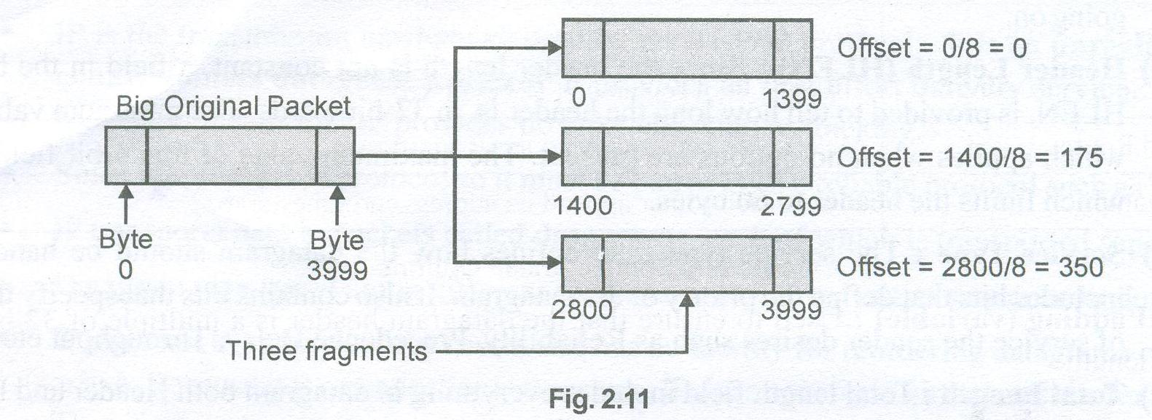

As shown in above diagram the IP packet contains 4000 bytes numbered from 0 to 3999 bytes fragmented into 3 fragments. The offset is measured in units of 8 bytes.

- Time to Live - Time to live always gets specified in terms of number of hops that must need to get traversed by the packet to reach at the destination host. This field gets initiated by some initial value. As the datagram travels router by router, this value gets decremented by 1. If this value gets decremented to zero before reaching at the destination host, the datagram gets discarded.
- Protocol – This field defines which upper layer protocol data are encapsulated in datagram like TCP or UDP.
- Header checksum – This field gets applied over the header to detect errors, if any. Because usually header fields gets changed during transmission.
- Source IP address – This field specifies the IP address of the sender’s host.
- Destination IP address – This field specifies the IP address of the receiver’s host.
- Options – It’s a 1 byte field used to specify one of the following things –
  - Security – Specifies the secrecy of the datagram.
  - Strict Source Routing – Gives the complete path to be followed.
  - Loose Source Routing – Gives the list of those routers which must get traversed.
  - Record Route – Makes each router appends its IP address.
  - Timestamp – Makes each router to append its timestamp.

IP ADDRESSING

- IP addresses are different from the physical addresses that identify the individual devices.
- All IP addresses are 32 bits long and are used in the source address & destination address fields of IP packets.
- Each such kind of address is defined under 3 fields – Class type, N/W Id & Host Id.

Class Type | N/W Id | Host Id

There are different classes based on these fields –

- Class A – The format of it is given below –
1 bit 7 bits 24 bits
0 | N/W Id | Host Id
Range of class A: 0.0.0.0 to 127.255.255.255

- Class B – The format of it is given below –
2 bits 14 bits 24 bits
10 | N/W Id | Host Id
Range of class B: 128.0.0.0 to 191.255.255.255
- Class C – The format of it is given below –
3 bits 21 bits 8 bits
110 | N/W Id | Host Id
Range of class C: 192.0.0.0 to 223.255.255.255
- Class D – The format of it is given below –
4 bits 28 bits
1110 | Multicast address
Range of class D: 224.0.0.0 to 239.255.255.255
- Class E – The format of it is given below –
4 bits 28 bits
1111 | Reserved for future use
Range of class D: 224.0.0.0 to 255.255.255.255

SUBNETTING

By studying the previous topic we have come to a point of thought, IP address is of 32 bit long. One part of it indicates network ID and other part indicates host ID or router ID. To reach at particular host, we have to first reach at network using net ID then host using the host ID. We call this a two level of hierarchy in addressing. With this scheme, the organization is limited to two level of hierarchy. The host cannot organize into groups and all of the hosts are at same level. The organization has one network and many hosts. See the diagram below -

<Diagram 2.23 from RTU Book>
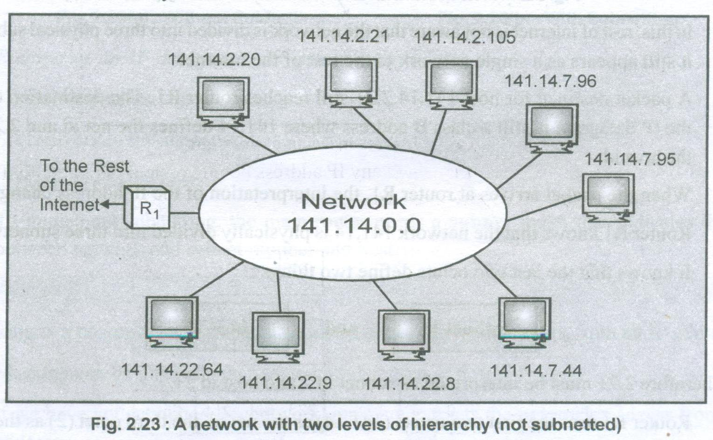

One solution to this problem is Subnetting. This solution is to allow a network to be split into several parts for internal use but still act like a single network to the outside world. Division of network into smaller networks is called subnetwork.
<Fig 2.24 from RTU Book>
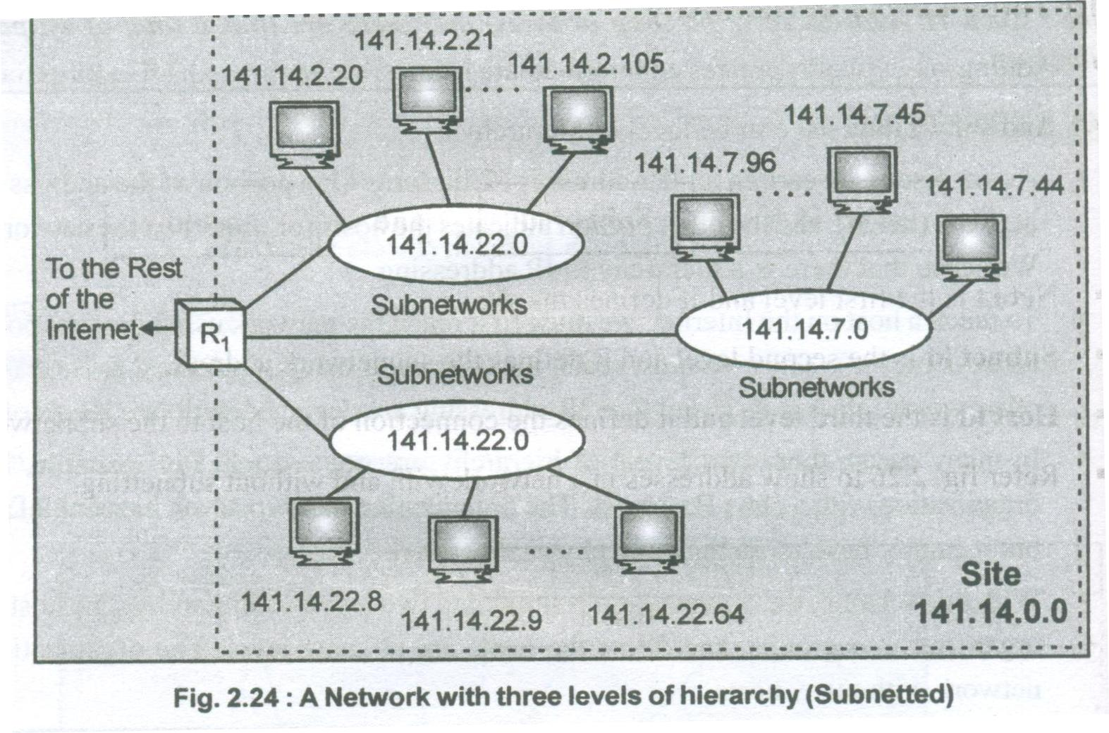

Based on this diagram we can say that router uses IP address bifurcated into three categories –

141.14.2.21 where 141.14 reflects net ID, .2. reflects subnet ID & .21 reflects host ID.

MASKING
Masking is a process to extracts out the address of the physical network from IP address. Masking can be done whether we have subnetting or not. Two conditions are there-
- If we have subnetted the network ( that is if we have partitioned the network into levels of hierarchy) then we can extract out the subnetwork address from IP address.
- If we have not subnetted the network then we can extract out the network address from IP address.
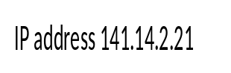
Network Address
141.14.0.0
MASK
255.255.0.0

Subnetwork Address
141.14.2.0
MASK
255.255.255.0

Masking is of two types –

Boundary Level Masking: In this masking, the following rule gets followed –
- The bytes in the IP address that correspond to 255 in the mask will be repeated in the
subnetwork address.
- The bytes in the IP address that correspond to 0 in the mask will change to 0 in the subnetwork address.

For eg. –

IP address: 45 . 23 . 21 . 8
Mask 255 . 255 . 0 . 0
________________________________________________
45 . 23 . 0 . 0 ( This is N/w address)

IP address: 45 . 23 . 21 . 8
Mask 255 . 255 . 255 . 0
________________________________________________
45 . 23 . 21 . 0 ( This is SubN/w address)

Non – Boundary Level Masking: In this masking the following rules get followed –
- The bytes in the IP address that corresponds to 255 in the mask will be repeated in the subnetwork address.
- The bytes in the IP address that corresponds to 0 in the mask will change to 0 in the subnetwork address.
- For the remaining byte, use the bit wise AND operator.
For eg. –

IP address: 45 . 123 . 21 . 8
Mask: 255 . 192 . 0 . 0
_________________________________________________________
45 . 64 . 0 . 0 (This is subnetwork address)

123 : 0 1 1 1 1 0 1 1 (in binary)
192: 1 1 0 0 0 0 0 0 (in binary)
_____________________________________
64: 0 1 0 0 0 0 0 0 (this value came by bitwise AND operator)

SUPERNETTING:

Every class defines some range. This means that every class defines the particular number of systems or hosts to be accommodated in that range of particular class. Now suppose if class C’s range can accommodate 256 hosts in its range and one has to deploy 1024 hosts of C class in the network than this situation can become cumbersome. To tackle this kind of situation we have phenomena of SUPERNETTING. In Supernetting an organization combines several C blocks to create a large range of addresses that is several networks are combined to create a supernetwork.
By doing so, the organization can apply for a set of class C block instead of just one.

